

Using Reference Fields

Items highlighted in yellow are tasks for you to complete
Items in Blue are help tips

A Table of Contents usually appears at the beginning of a document to summarise the contents of the documents and the pages they appear on. The advantage in using a Table of Contents is its ability to automatically change when the page on which a section starts changes through editing, formatting etc.

For a table of contents to be established, the sections of the document to be summarized, must be indicated by using Headings from the Style box. This chapter assumes you have completed the chapter on Styles.
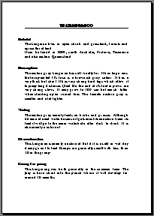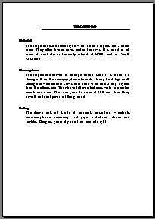
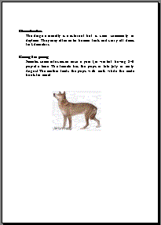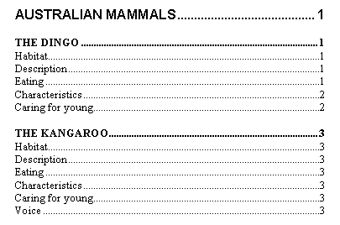

In this Chapter you will

- Create a Table of Contents
- Create an Index
- Enter Cross-references
- Enter Footnotes and Endnotes

Format Document to enable Automatic Table of Contents

A Table of Contents is based on text that has been formatted with headings styles as in the previous section on Styles.

NOTE: You should have completed Chapter 2 before attempting this chapter

- Open the file Australian Mammals

- Format the Main heading with a Heading 1 style (Australian Mammal)

- Format the Sub headings with a Heading 2 style (The Dingo, The Kangaroo etc.)
- Format the Minor headings with a Heading 3 style (Habitat, Description etc.)
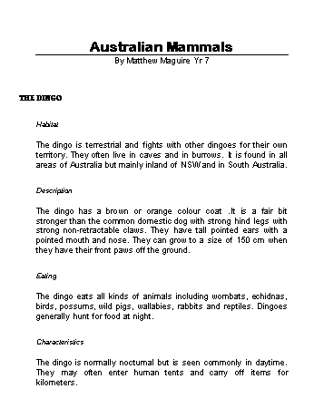

Create a Table of Contents

A table of contents is easy to create once Heading styles have been applied.

- Move the Insertion point to the start of the document where the Table of Contents is to appear

- Click on Insert ➢ Index & Tables in the Menu bar

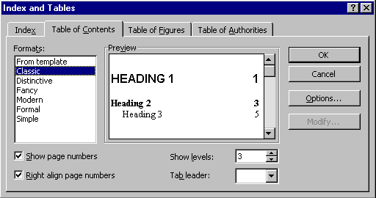
- Click on the Table of Contents tab
The format of the Headings can be set here.
Choose whether to show the page numbers of the contents
Choose to show page numbers to the right

The Index and Table dialog box will appear as shown above.

- Experiment with the options and check the Preview to see the result

- Click on OK when happy with the result to produce the Table of Contents

Your Table of Contents should appear similar to the following depending on the selections you made.

Updating a Table of Contents

If changes are made to a document then the Table of Contents should be updated. The Table of Contents will not update until Word is instructed to update it.

- Insert a paragraph before the paragraph Habitat in the Dingo section using the following text

Introduction

In this chapter we will look at the habitat of the dingo. How it finds food to eat and cares for its young. The general characteristics of a dingo are also discussed.

- Format the heading with a Heading 3 style

The Table of Contents will not have updated yet.

- Highlight the Table of Contents so it is grayed out

- Press [F9] on the keyboard

The Update Table of Contents dialog box will appear.
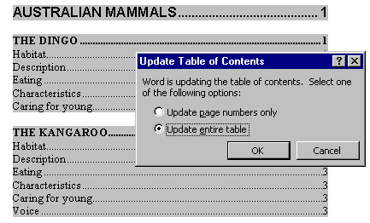

- Click on Update entire table to include the new heading

- Click on OK

The Table of Contents will be updated to include the new heading

- Save and Close the file

- Repeat to insert a similar paragraph for the Kangaroo (Use copy and paste to enter the Introduction and just edit Dingo to be Kangaroo)

- Select the Table of Contents and press the [F9] key to update it

- Repeat again for the other animals

- Save the file

Practice:

- Open the file Australian Cities

- Apply headings styles

Heading 1 to the names of the Cities

Heading 2 to Things to do and Places to see

- Create a Table of Contents at the start of the document

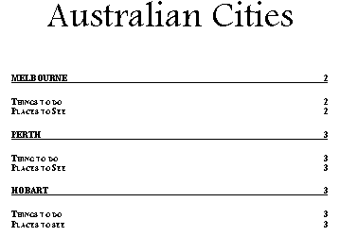

- Insert Page Breaks so each City starts on a New page

- Update the Table of Contents

- Close and Save the changes

Indexing

An Index gives readers page numbers for subjects they want to look up in a printed document. It usually appears at the end of a document.

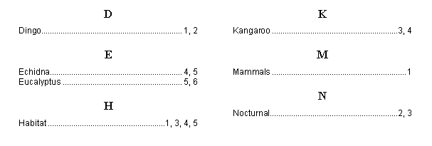

- Open the file Australian Mammals if not already open

- Highlight the word Mammals in the document

- Click on Insert➢Index and Tables in the Menu bar

- Click on the Index tab

- 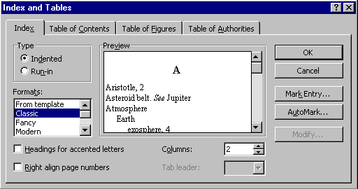Click on Mark Entry in the Index tab
Mark Entry

The Mark Entry window will appear as shown on the following page.

The Mark Index Entry dialog box will stay on the screen while you mark all the words that are to appear in the Index.
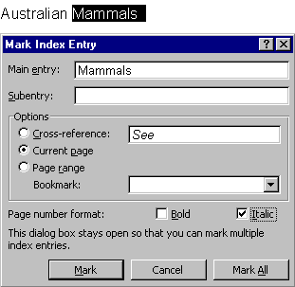
- Click on Mark to mark the mammals entry

- Highlight the word dingo

- Click on the Main Entry box to activate the Mark Index Entry box

- The word dingo will appear – edit it so it has a capital letter

- Click on the Mark All button

- Highlight the word kangaroo

- Click on the Main Entry box to activate the Mark Index Entry box

- The word kangaroo will appear – edit it so it has a capital letter

- Click on the Mark All button

- Continue to mark these words
- Nocturnal
- Habitat
- Echidna
- Any others you like

- Click on the Close button

Inserting an Index

Once the entries for an Index have been marked the Index can be created.

- Position the insertion point at the end of the document

- Click on Insert ➢ Index and Tables in the Menu bar

- 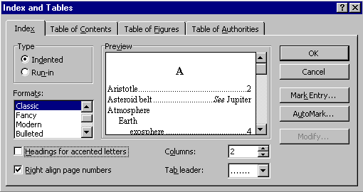Click on the Index tab
Check here for page numbers to the right
Select dots for leader to page number

- Click on OK

The index will appear with all marked entries. The page numbers may vary depending on how you formatted your headings.

Editing an Index

- Find and select the word eucalyptus

- Click on Insert ➢ Index and Tables in the Menu bar

- Click on the Index tab if necessary

- Click on Mark Entry

- Edit the word Eucalyptus in the Main entry box to have a capital E as shown below
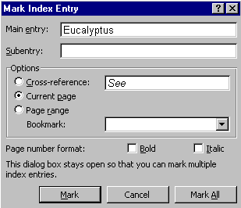
- Click on Mark

- Click on Close

- Highlight the Index so it appears grey

- Press the [F9] key to update the Index – Eucalyptus should now appear in the index.

Practice:

- Open or switch to the file Australian Cities

- Create an Index with the following entries
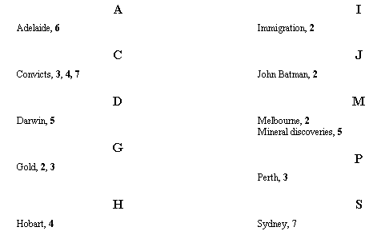

- Save and Close the file

Cross Referencing

You can create a cross-reference eg. “See table 6 on page 22”, to refer to an item in another location in the same document or a different document. If the item you’ve referred to changes, eg. Table 6 becomes table 5, or it moves from page 22 to page 23, you can update the cross-reference without retyping it.

Cross – Reference to a Heading

The heading you are creating a cross-reference to must be set in the style of one of the headings from the style box.

- Open the file CrossRef from your student disk

You are going to create some cross references from the objectives on the first page to the appropriate areas in the document.

- Click at the end of the first objective point and type the text (See as a lead up to the reference

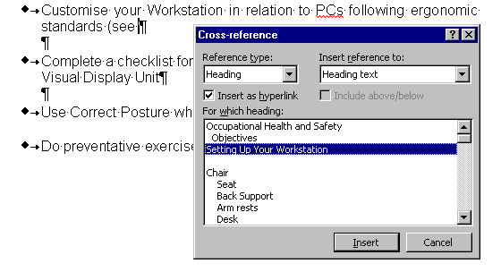
- Click on Insert ➢ Cross-reference in the Menu bar

- Click on the Reference Type box and click on Heading
- Click on Insert reference to box and click on Heading Text
- Click on Setting Up Your Workstation in the For which heading box
- Click on Insert and Close to create a cross reference as shown on the following page
- Type the ) symbol to close the brackets
- Create a Cross Reference for the 2nd Objective ; "Complete a Checklist...." as shown below

You will have to scroll down through the list of headings.
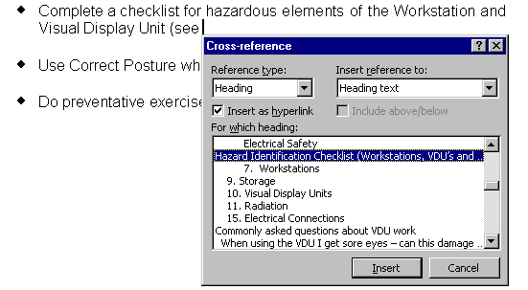
- Repeat for the last point to create a reference to the section on exercises

The set of points should look like that shown below.

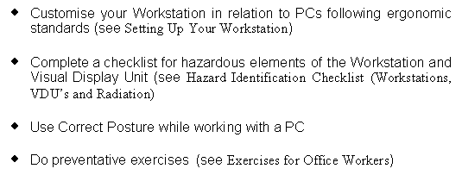
Now that the cross references have been inserted, move through the document to the ‘Objectives”. Move the mouse over the (see Setting up Your Workstation), the mouse changes to a pointing hand.

- Click

You will be moved through the document to the explanation of how to set up your workstation. Try the other cross references and see the results.

Reference to a Page Number

Now for the reference to the page number on which the heading appears.

- Position the Insertion point at the end of the first cross reference Setting Up Your Workstation

- Type on page

- Click on Insert➢Cross-reference in the menu bar

- Ensure that Setting up your workstation is highlighted in the For which heading box as shown below

- Click on Page Number in the Insert Reference To box

- Click on the Insert button and then the Close button

The Page number 2 should appear at the end of the Cross-reference.
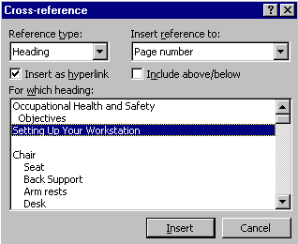

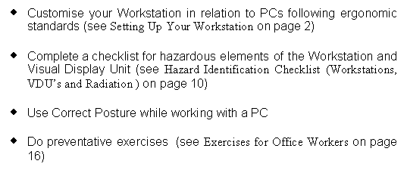
- Repeat the process to create a page number Cross-reference to the other two sections as shown below

Updating a Cross-reference

If the Heading were to move or the text in the heading were to change the reference to the heading would change when the document is updated.

- Edit the text of the heading on page two to read Organising Your Workstation

- Edit the text of the heading on page ten to read Hazard Checklist (Workstations, VDU’s and Radiation)

- Edit the text on page 16 to read Office Exercises for Workers

- Display the first page, the references to the headings should still read as the original headings.

The Cross-references must be updated.

- Click on Edit ➢ Select All to highlight the whole document

- Press the [F9] key on the keyboard

The Cross-references will be updated in the document.

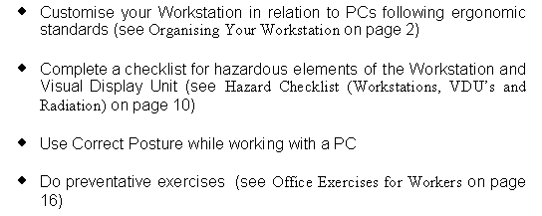

Practice :

- Try Inserting some extra page breaks so the pages these headings appear on will change

- Update the Cross-references

- Save & Close the file

Practice:

- Repeat the process creating the following cross-references in the Australian Mammals document. Add the text and cross references as shown in the bordered text below.

- In the Kangaroo section on Caring for Young

Caring for young
The kangaroo gives birth generally in the summer time. The joey is born straight into the pouch where it will develop for around 10 months.
For other examples of marsupials, see THE KOALA on page 6 and THE WOMBAT on page 9.

- In the Echidna section on Caring for Young

Caring for young
The female echidna lays one or two eggs after a period of 9-27 days. These eggs are put into a pouch for a time of 10-12 days. The young echidna is carried around in a pouch until it can walk.
For another example of a monotriem, see THE PLATYPUS on page 7

- Close and Save the file

Endnotes and Footnotes

Footnotes appear at the end of each page while endnotes appear at the end of a chapter or document. They provide an area for further reference or comment while not taking up space in the main document or diverging from the theme. They are very common in text books and reports to reference other works, special explanations or terms.

There are two parts to a footnote or endnote:
- the text that appears in the footnote or endnote
- the marker or number that appears within the main part of the document as a reference to that text.

To Insert a Footnote or Endnote

- Open the file Phone Rates
This letter is to be sent to customers. It contains some great marketing ploys. However there are extra notes to add that clarify the claims and offers. You will add these to the letter using footnotes.

- Click on View ➢ Page Layout in the Menu bar
- Click after the first reference to STD where the note reference mark is to be inserted
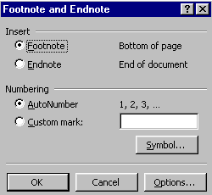
- Click on Insert ➢ Footnote in the Menu bar
- Click on Footnote or Endnote and OK

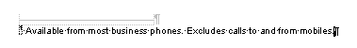
- Type the text shown below for the note in the footnote pane

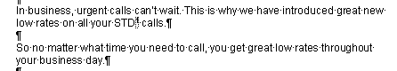
- When finished click next to the reference mark to continue typing

NOTE: At any time you can check the contents of a footnote just by moving the mouse over the top of it. A note will appear with the contents of the footnote.
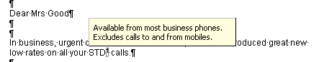

View Footnotes and Endnotes

In Page Layout View the footnotes and endnotes are located at the base of the page. They can be edited as normal text. In Normal View, the footnotes and endnotes can only be viewed in the Footnote and Endnote pane that is accessed via View➢Footnotes in the Menu bar.

- Click on View ➢ Normal View then View ➢Footnotes in the Menu bar

Normal View of Footnotes and Endnotes
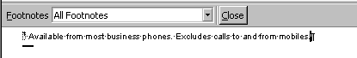

Page Layout View of Footnotes and Endnotes

Practice: Footnotes and Endnotes

- Insert 3 more footnotes using this text

- 7am – 7pm Monday to Friday.
- A call connection fee of 17 cents applies per Fixed to Mobile phone call.
- A free call unless from a mobile phone.

The footnotes should be inserted in the following locations.

So no matter what time you need to call, you get great low rates throughout your business day.

Take a look at the rates to see for yourself how affordable it is to have quality and reliability of the Ringaling network working for your business.

In addition to our new, lower 7am to 7pm STD rates, we’ve reduced the cost of calling Ringaling Mobile phone from a fixed phone, starting at 32c per minute.

What’s more, because all Ringaling long-distance calls are charged by the second (instead of blocks of time) you only pay for the time you use.

If you’d like to know more about our great new STD and Mobile call rates, please don’t hesitate to CALLFREE 1800 467 444 during business hours.

Move, copy, or delete footnotes and endnotes

Word will automatically renumber footnotes and endnotes when they are moved, copied or deleted.

To Move a Footnote or Endnote

- Highlight the reference mark of the note to be moved or copied

- Drag it to the new location OR use Cut or Copy and Paste

The reference marks will be renumbered for the new order.

Delete a footnote or an endnote

- Highlight the footnote or endnote to be deleted

- Press the [Delete] key

Restart Reference Numbers from 1 on each page or section

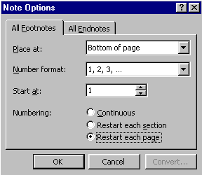
- Click on Insert ➢ Footnote in the Menu bar
- Click on Options
- Click the All Footnotes or All Endnotes tab.
- Click on the Numbering option required

- Click on OK and OK to close the Footnotes dialog box

- Save and Close

7am – 7pm Monday to Friday.
A call connection fee of 17 cents applies per Fixed to Mobile phone call.
A free call unless from a mobile phone.

